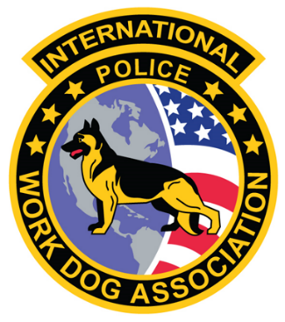
Welcome to the 2025 IPWDA Nationals

Dear IPWDA Members
As President of the International Police Work Dog Association, it is my honor to welcome you to the 2025 IPWDA Nationals, taking please October 4-9, 2025, in Fayetteville, North Carolina.
This year’s Nationals are proudly hosted by the Fayetteville Police Department, Cumberland County Sheriff’s Office, Hope Mills Police Department and the Harnett County Sheriff’s Office. Their commitment and support have made it possible for us to come together for a week of professional growth and camaraderie.
The Nationals represent the very best of our association – an opportunity for members from across the United States to come together for training, certification, learning and the exchange of knowledge. Just as importantly, they allow us to build and strengthen the bonds that unite our K9 community.
Hotel Information, registration details, schedules for the weekend are enclosed in this letter. Once you arrive at the Crown Coliseum packets will be provided to each of you for the upcoming weeks events and festivities.
I look forward to an outstanding week and to the continued demonstration of professionalism, dedication, and teamwork that define IPWDA.
Thank you for your patience and for attending this year’s Nationals and for your ongoing commitment to the mission of our organization.
Respectfully

Tracy A Campbell
President
International Police Work Dog Association

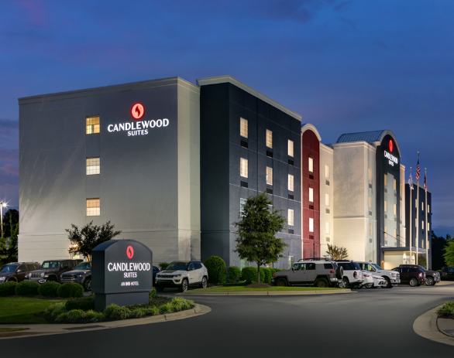
HOTEL ACCOMODATIONS

Candlewood Suites
4108 Legend Avenue
Fayetteville, North Carolina 28303
(910) 868-0873
NOTE: [Executive Board & Master Trainers]

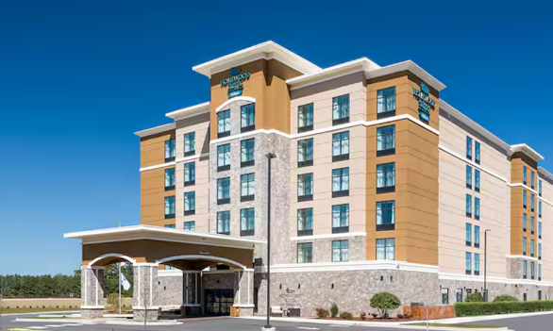
Homewood Suites by Hilton
4028 Legend Avenue
Fayetteville, North Carolina 28303
(910) 672-7800
NOTE: [IPWDA Members]

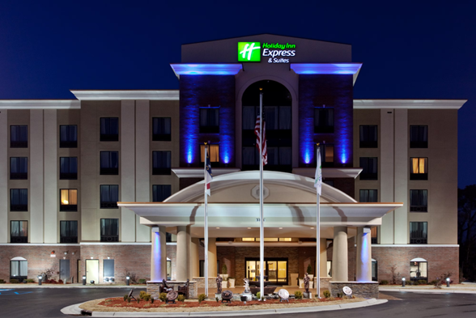

Holiday Inn Express Hope Mills
3111 North Main Street
Hope Mills, North Carolina
(910) 429-9990
NOTE: [IPWDA Members]

2025 IPWDA SCHEDULE

REGISTRATION – GENERAL MEMBERSHIP MEETNG AND BANQUETS
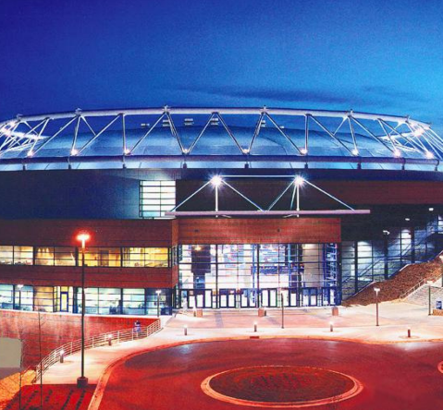
Crown Coliseum Complex
1960 Coliseum Drive
Fayetteville, NC 28306
(910) 438-4100

DAILY SCHEDULE

Saturday, October 4, 2025

0900-1200 hours Executive Board meeting – Crown Coliseum Complex
1200-1300 hours Lunch
1300 -1500 hours On-Line Testing – Crown Coliseum Complex
1500-1700 hours Oral Boards – Crown Coliseum Complex

Sunday, October 4, 2025
0900-1200 hours Executive Board meeting – Crown Coliseum Complex
1200-1300 hours Lunch
1200 -1500 hours Registration – Crown Coliseum Complex
1500-1800 hours Membership Meeting - Crown Coliseum Complex
1800-2100 hours Banquet - Crown Coliseum Complex

Monday, October 6, 2025

0800 - 0815 hours Daily Meeting – Crown Coliseum Complex
0900 - 1700 hours Certification / Training – See Schedule in Packet
0900 - 1200 hours Swift Water Training – FTCC
1200 - 1300 hours Lunch
1300 - 1600 hours Swift Water Training – FTCC
1500 - 1700 hours Vet Class – Fayetteville PD Training Center
1700 - 2100 hours Hospitability / Evening
Tuesday, October 7, 2025

0800 - 0815 hours Daily Meeting – Crown Coliseum Complex
0900 - 1700 hours Certification / Training – See Packets
0900 - 1200 hours Swift Water Training – FTCC
1200 - 1300 hours Lunch
1300 - 1600 hours Swift Water Training – FTCC
1500 - 1700 hours Vet Class – Fayetteville PD Training Center
1700 - 2100 hours Hospitability – Crown Coliseum Complex

Wednesday, October 8, 2025

0800 - 0815 hours Daily Meeting – Crown Coliseum Complex
0900 - 1700 hours Certification / Training
0900 - 1200 hours Swift Water Training – FTCC
1200 - 1300 hours Lunch
1300 – 1700 hours One Handed Pistol – Fayetteville PD Training
1300 - 1600 hours Swift Water Training – FTCC
1500 - 1700 hours Repelling - FTCC Fire Rescue Training Facility
1900 – 2100 hours Banquet - Crown Coliseum

Thursday, October 9, 2025

0800 Teams Depart
0800 - 0815 hours Daily Meeting – Crown Coliseum Complex
0900 - 1700 hours Problem Solving / Certification / Training
0900 - 1200 hours Swift Water Training – FTCC
1200 - 1300 hours Lunch
1300 – 1700 hours Clean-Up

HOST COMMITTEE PHONE NUMBERS

Fayetteville Police Department
Sgt. Candice Snyder 724-594-7287

Cumberland County Sheriff’s Office
Lt. Mark Lee 910-916-2088

IPWDA President
Tracy A Campbell 910-850-6192

IPWDA Treasurer
Heather Napieralski 910-624-4193

Note: Once you arrive at the Crown Coliseum we will have signs and Host Committee Officers in uniform for direction into the Coliseum.

Master Trainers needing transportation please ensure you make contact with Sgt. Snyder prior to your departure so we can ensure we are ready for your arrival.

Master Trainers once you arrive at the hotel you will only need to give them your name and Heather has taken care of the reservations.

Any questions do not hesiste to reach out to us.

